SJTU Thesis Format
- Cover (see page2)
- Detailed Title pages (See page 3)
- Original Writing Statement (See page 4)
- Letter of authorization(for file your thesis in SJTU Library for academic purpose , see page 5)
- English Abstract(see page 6)
- Content of thesis(see page 7)
- Body of thesis
- References(see page 9)
- Appendix（if applicable, see page 13)
10. Acknowledgements (see page 14)
11.Outcomes you achieved during pursue the degree（if applicable, see page 15）

(* Please note that all the materials could be found below, and you can just take the format as your reference. For any question on thesis format, you can find some examples in this document.)

Cover

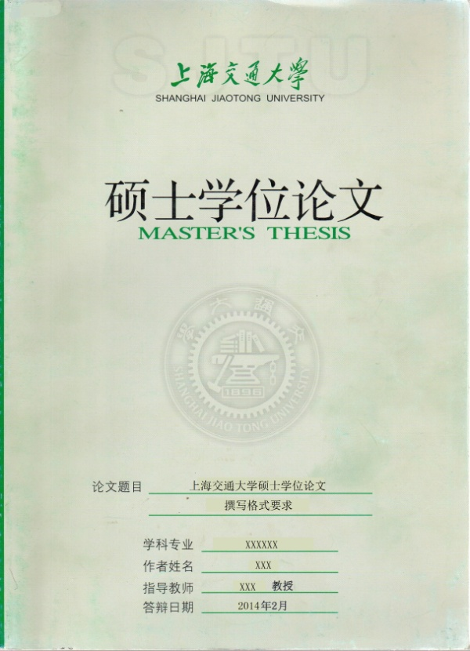
Standard cover used in SJTU. Go to Postgraduate Affairs Office to pick up 5 copies of the cover.
A white space and his title should after your supervisor’s name
Font：宋体，size 14，Bold。

Dissertation Submitted to Shanghai Jiao Tong University for the Degree of Master

Study of key successful factors to lead Lean Manufacturing in Small and Medium enterprises in China

Candidate： | □□□
Student ID: | □□□□□□□□□□
Supervisor： | Prof.□□□
Academic Degree Applied for： | Master of Science
Speciality： | Mechanical Engineering
Affiliation： | School of Mechanical Engineering
Date of Defense： | January, 2016
Degree-Conferring-Institution： | Shanghai Jiao Tong University

Shanghai Jiao Tong University
Declaration of Originality of Thesis

I solemnly declare that the thesis I submitted is based on my own original work, conducted under the supervision of my supervisors. Apart from the citations, no part of this thesis contains the published work by other individual and/or group. All the individuals or groups that contribute significantly to this thesis have been explicitly acknowledged in the thesis. I am legally responsible for the truthfulness of this declaration.

Signature of the Author:

Date:

Shanghai Jiao Tong University
Thesis Copyright Authorization

I comprehensively understand the regulations on the retention and use of theses in Shanghai Jiao Tong University (SJTU) and therefore, agree SJTU to retain my thesis and submit the copies to related national departments or institutes, allowing the thesis to be consulted or borrowed. I authorize SJTU to incorporate all or part of my thesis into the relevant database for searching, and SJTU has the right to retain and compile the thesis by photocopying, scanning or microprinting.

This thesis is:
□ Confidential. (The Authorization will take effect after _____ years.)
□ Public.
(please tick by “√”)

Signature of the author: Signature of the supervisor:

Date: / / Date: / /

Study of key successful factors to lead Lean Manufacturing in Small and Medium enterprises in China

ABSTRACT

Shanghai Jiao Tong University (SJTU) is a key university in China. SJTU was founded in 1896. It is one of the oldest universities in China. The University has nurtured large numbers of outstanding figures include JIANG Zemin, DING Guangen, QIAN Xuesen, Wu Wenjun, WANG An, etc.
SJTU has beautiful campuses, BaoZhaolong Library, Various laboratories. It has been actively involved in international academic exchange programs. It is the center of CERNet in east China region, through computer networks, SJTU has faster and closer connection with the world.

KEY WORDS: SJTU, key university, outstanding figure, beautiful campus

ABSTRACT Ⅲ
CONTENT Ⅳ
Chapter 1:Introduction 1
1.1background research 4
1.2 15
1.2.1 17
1.2.2 19
1.3 21
Chapter 2: literature review 23
2.1 24
……
REFERENCE 37
APPENDIX 1 53
AcknowledgementS 59
Academic Achievements 90

Body of your thesis

Example:
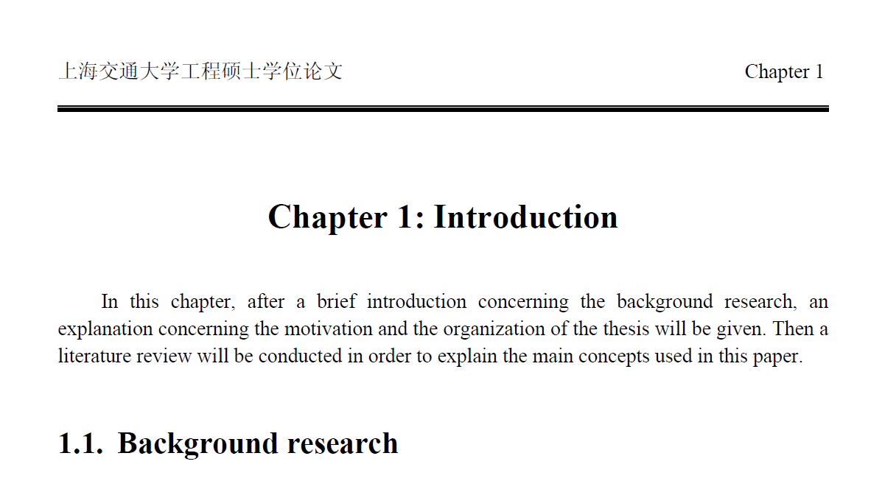
…

REFERENCES
（*Please note that you should list the English version references in the alphabetic order first and then list the Chinese references）
Format for Reference

Categories of reference identifier:
[M]——Monograph [C]——ConferenncePrceeding
[N]——Newspaper [J]——Journal Article
[D]——Academic dissertation
[R]——Report
Electronic reference identifier：
［DB/OL］—— database online
［M/CD］——monograph on CD-ROM
［EB/OL］——electronic bulletin board online
Others——“Z”

More examples:
Journal Article：
[Order] corresponding author.Title[J]. Journal Name，Year，Volume(Issue No.)：startpage-endpage number.
[1]张滋黎，邾继贵，周虎，等.一种新型自动激光经纬仪引导跟踪方法[J].光电工程，2010，37(4)：1-7.
[2]GREEN D H, WALLACE M E, CALMS R B, et al. Mantle Metasomatism by Ephemeral Carbonate Melts [J]. Nature, 1988, 336: 459-462.

monograph：
[Order] corresponding author.monograph name/书名book name[M]. publish place(publish city)：publisher，year of publish：startpage-endpage number.
[3] 葛家澍，林志军. 现代西方财务会计理论[M]. 厦门：厦门大学出版社，2001：42-43.
[4] Gill R. Mastering English Literature [M]. London: Macmillan, 1985: 42-45.

Conferennce Prceeding：
[Order] corresponding author.ConferenncePrceedingName[C]. publish place(publish city)：publisher，year of publish：startpage-endpage number.
[8] 伍蠡甫.西方文论选[C]. 上海：上海译文出版社，1979：12-17.
[9] SpivakG. “Can the Subaltern Speak?”[A]. In C.Nelson& L. Grossberg(eds.). Victory in Limbo: Imigism [C]. Urbana: University of Illinois Press, 1988, pp.271-313.

Article from anthology：
[Order] corresponding author. Title [C]// conference name, conference venue, conference time. Publish place：publisher，year of publish：startpage-endpage number.
[10]FOURNEY M E. Advances in Holographic Photoelasticity [C]//American Society of Mechanical Engineers, Applied Mechanics Division Symposium on Applications of Holography in Mechanics, University of Southern California, Los Angeles, California, August 23-25,1971. New York：ASME，1971：17-38.

Academic dissertation：
[Order] corresponding author.Tiel[D]. publisher’s city：publisher’s employer，year of publish：startpage-endpage number.
[11] 李百华. 基于CCD的汽车发动机曲轴自动检测系统的研制[D]. 重庆：重庆大学，2005.

Patent：
[Order] patent owner. Paten name：country，patent number[P]. announcement date.
[12 ] 姜锡洲. 一种温热外敷药制备方案：中国，88105607.3[P]. 1989-07-26.

Others：
[Number] First author.Title[Z]. publishing place(city name)：publisher，Year of publish：startpage-endpage number.
[13]MARPOSS Co Ltd. M110 New Automatic Measuring Machine for CheckingShafts[Z]. Bentivoglio, Italy: MARPOSS, 2011.

Electronic reference：
[14] Perceptron Inc. Applications Roof Load [EB/OL]. [2013-10-27]. http://www.perceptron.com/index.php/en/applications/roof-load.html.

More examples:

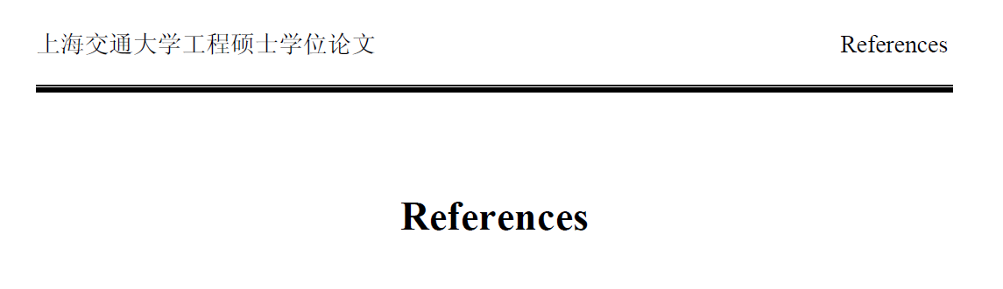
[1]FOURNEY M E. Advances in Holographic Photoelasticity [C]//American Society of Mechanical Engineers, Applied Mechanics Division Symposium on Applications of Holography in Mechanics, University of Southern California, Los Angeles, California, August 23-25,1971. New York：ASME，1971：17-38.
[2] Gill R. Mastering English Literature [M]. London: Macmillan, 1985: 42-45.
[3]GREEN D H, WALLACE M E, CALMS R B, et al. Mantle Metasomatism by Ephemeral Carbonate Melts [J]. Nature, 1988, 336: 459-462.
[4] SpivakG. “Can the Subaltern Speak?”[A]. In C.Nelson& L. Grossberg(eds.). Victory in Limbo: Imigism [C]. Urbana: University of Illinois Press, 1988, pp.271-313.
[5] Perceptron Inc. Applications Roof Load [EB/OL]. [2013-10-27]. http://www.perceptron.com/index.php/en/applications/roof-load.html.
[6]MARPOSS Co Ltd. M110 New Automatic Measuring Machine for CheckingShafts[Z]. Bentivoglio, Italy: MARPOSS, 2011.
[7] 李百华. 基于CCD的汽车发动机曲轴自动检测系统的研制[D]. 重庆：重庆大学，2005.
[8] 姜锡洲. 一种温热外敷药制备方案：中国，88105607.3[P]. 1989-07-26.
[10] 葛家澍，林志军. 现代西方财务会计理论[M]. 厦门：厦门大学出版社，2001：42-43.
[11] 伍蠡甫.西方文论选[C]. 上海：上海译文出版社，1979：12-17.
[12]张滋黎，邾继贵，周虎，等.一种新型自动激光经纬仪引导跟踪方法[J].光电工程，2010，37(4)：1-7.

APPENDIX 1（Please attach APPENDIX if applicable）

Example:
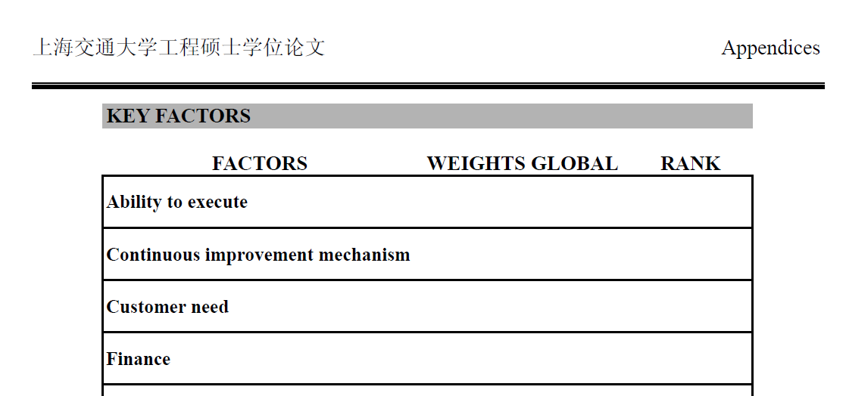

ACKNOWLEGEMENTS

Example:

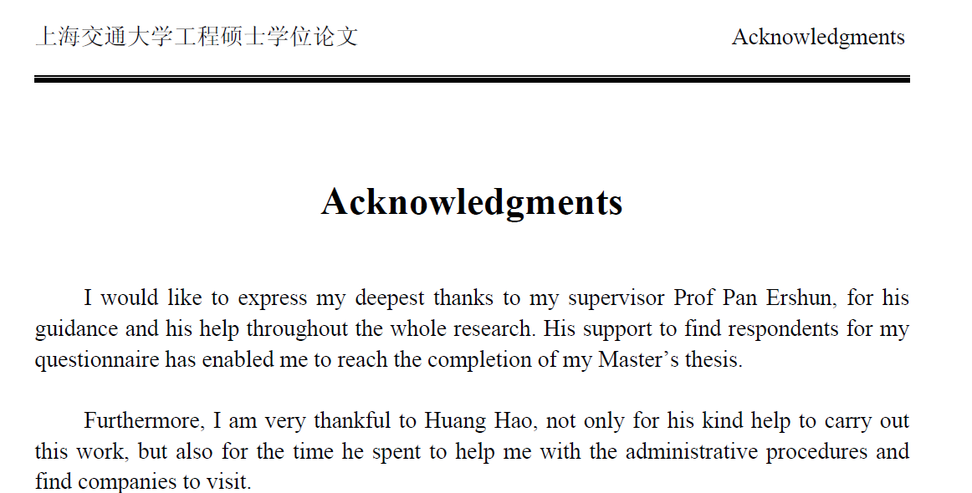

Academic achievements you have during pursue the degree
(if applicable)

